C.S. LEWIS AND THE TRUTH OF BALDER
Dr. Bradley Birzer, in The Imaginative Conservative, March 22, 2019
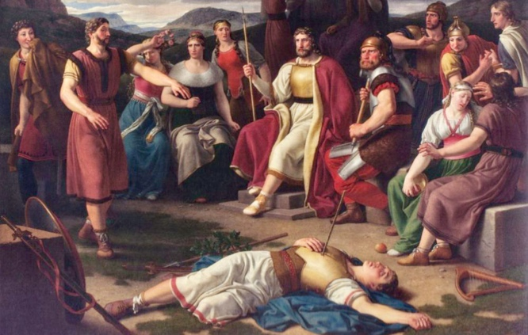
C.S. Lewis’ famous conversation with Hugo Dyson and J.R.R. Tolkien, allowed him, for the first time in his life, to see that Christianity expresses not just myth, but true myth, something profoundly real, “a myth working on us in the same way as the others, but with this tremendous difference that it really happened.”

As is well known, C.S. Lewis converted to Christianity in the fall of 1931 after a long, late night discussion with Hugo Dyson and J.R.R. Tolkien on September 13, 1931. As he beautifully described the evening in a letter to a close friend, Lewis wrote: “We began (in Addison’s walk just after dinner) on metaphor and myth—interrupted by a rush of wind which came so suddenly on the still, warm evening and sent so many leaves pattering down that we thought it was raining.” One must wonder if it could have been more inspirational or romantic? Yes, it turns out, it could. “We all held our breath, the other two appreciating the ecstasy of such a thing.” A full month later, the determined Lewis offered a few more details to his correspondent. What he learned from Dyson and Tolkien that night, he wrote, was that “if I met the idea of sacrifice in a Pagan story I didn’t mind it at all: again, that if I met the idea of a god sacrificing himself to himself . . . I liked it very much and was mysteriously moved by it: again, that the idea of the dying and reviving god (Balder, Adonis, Bacchus) similarly moved me provided I met it anywhere except in the Gospels.” The mythic versions, he admitted, gave him a certain distance that allowed him, ironically, to embrace the very essence of the story, if find the accidents of the stories unbelievable. The conversation with Dyson and Tolkien, though, allowed Lewis, for the first time in his life, to see that Christianity expresses not just myth, but true myth, something profoundly real, “a myth working on us in the same way as the others, but with this tremendous difference that it really happened.”

Understandably, given Lewis’s status as the greatest Christian apologist of the twentieth century, this explanation has perplexed Christians for over half a century. Is Christianity myth or truth? Is it fact or not?
To understand this, one must take into account the myth that moved Lewis. Even though he mentioned three gods in his 1931 letter, he really cared most about Balder. “I had become fond of Longfellow’s Saga of King Olaf: fond of it in a casual, shallow way for its story and its vigorous rhythms,” Lewis recorded in his autobiography, Surprised by Joy. “But then, and quite different from such pleasures, and like a voice from far more distant regions, there came a moment when I idly turned the pages of the book and found the unrhymed translation of Tegner’s Drapa and read I heard a voice that cried, ‘Balder the beautiful is dead, is dead.’” The words seemed to have come from infinity itself, and Lewis had no context for them, knowing them only, somehow, to express truth. “I knew nothing about Balder; but instantly I was uplifted into huge regions of northern sky, I desired with almost sickening intensity something never to be described (except that it is cold, spacious, severe, pale, and remote) and then, as in the other examples, found myself at the very same moment already falling out of that desire and wishing I were back in it.”
The story of Balder is one of the oldest in the Northern tradition, and it makes its way into a number of different Scandinavian myths and sagas. Always referred to as Balder (Baldr, Baldar) the Beautiful or the Good and a son of Odin, he experienced terrible nightmares that suggested some imminent danger. Worried, Odin descended into Hel and raised the corpse of a dead witch, seeking her advice and knowledge. Trying to hide his identity from her, Odin forces her to speak, though she is beyond reluctant to do so. Finally exhausting herself beyond recovery, she names Odin as the desecrator of her death. Upset that she has discovered his identity, he curses her. “You are not a prophetess nor a wise woman,” he yells. “Rather you are the mother of three ogres.” Mockingly, she retorts: “Ride home, Odin, and be proud of yourself! No more men will come to visit me, until Loki is loose, escaped from his bonds, and the Doom of the Gods, tearing all asunder, approaches.”

When Balder explained his dreams to the other gods, they decided to weave as many spells of protection about him as possible, but they did this mostly by demanding an oath from all created things that they would not harm Balder. Becoming seemingly invincible, the gods amused themselves by attacking Balder, knowing him to be invulnerable. In the west of Valhalla, though, grew one tiny plant that the gods had neglected to tame, mistletoe. Learning of this, the trickster of tricksters, Loki, broke a stick from the mistletoe, giving it to the blind god, Hod. He then encouraged Hod to participate in the “hit Balder” games by attacking with the stick. Unwittingly, Hod killed Balder. Shocked beyond understanding, the gods realized they were mortal. They lost all confidence in themselves and desired to slay Loki for his fell deeds. Honoring Balder instead, the gods placed him upon the largest ship available, setting it afire. In grief, Balder’s wife dropped dead, and even a dwarf found himself accidentally kicked into the fire by a distraught Thor.

One of Balder’s brothers, Hermod rode into Hell itself to find Balder. There, he discovered his brother sitting “in a seat of honor.” As proof of his safety, Balder gave his brother a golden ring—Draupnir—to take to the world of the living and to Asgard, home of the gods. Hermod then sought all of the world to “weep for Balder,” thus releasing him from the dead. All creatures wept except for Thokk, a giantess who felt she owed nothing to the gods. “Let Hel hold what she has,” Thokk declared. With the death of the gods during Ragnarok, the seeress had told Odin when he had forced her from the sleep of dead, Balder will return and help make the world—if only for a time—a paradise. Even this, though, will ultimately fail, as the flying serpent Nidhogg will descend and carry the dead in his wings. Though unrelentingly pagan, Balder’s story—and the stories of his fellow gods—parallels the stories of Saul and Jesus in scripture.

As Lewis so wisely argued in the weeks following his conversion to Christianity: “The pagan stories are God expressing Himself through the minds of the poets, using such images as He found there, while Christianity is God expressing Himself through what we call ‘real things.’ Therefore it is true, not in the sense of being a ‘description’ of God (that no finite mind could take in) but in the sense of being the way in which God chooses to (or can) appear to our faculties.”

Balder is dead, to be sure. But, Christ is alive.

The featured image is “Baldr’s Death” (1817) by Christoffer Wilhelm Eckersberg (1783-1853

Bradley J. Birzer is the co-founder of, and Senior Contributor at, The Imaginative Conservative. He is the Russell Amos Kirk Chair in History at Hillsdale College and Fellow of the Ronald Reagan Presidential Library.

